54. JS Methods, Input Fields, Buttons, Query Selectors- 21 June2022

Today we will learn:

1] Create JS Controller Method

2] Calling JS Method on Button Click

3] Calling One JS Method from Other JS Method

4] return values from a JS Method (**get**)

5] Input Fields

6] query Selector (GET and SET)

* **For Single input field**
* **For Multiple Fields**

1] Create JS Controller Method

import SystemModstamp from '@salesforce/schema/Account.SystemModstamp';

import { LightningElement } from 'lwc';

export default class HelloWorld extends LightningElement {

    myMethod1(){

    }

}

2] Calling JS Method on Button Click

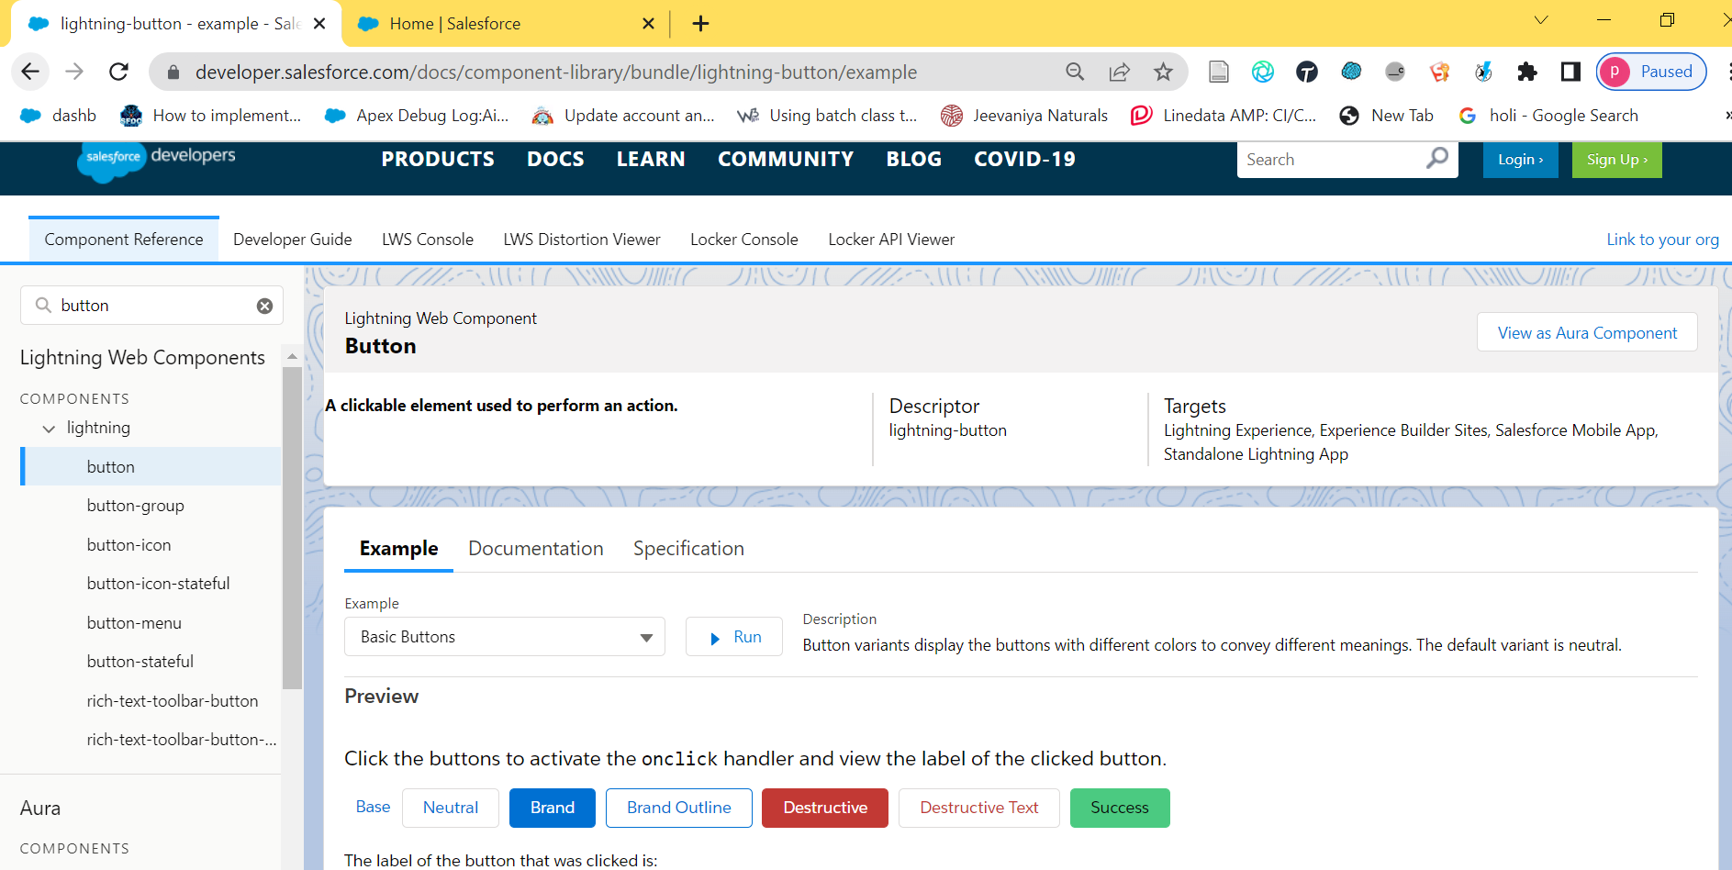

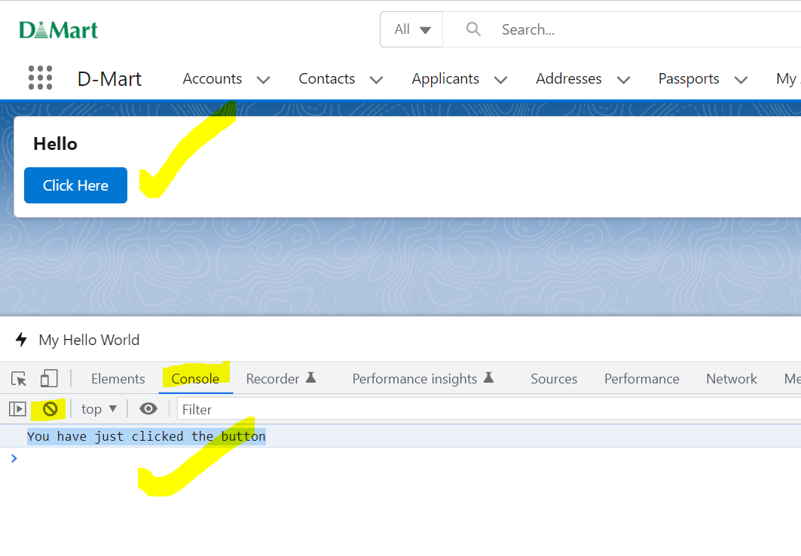

<template>

    <lightning-card  title="Hello">

        <lightning-button variant="brand" label="Click Here" title="Click Here" onclick={myMethod1} class="slds-m-left_x-small"></lightning-button>

    </lightning-card>

</template>

import SystemModstamp from '@salesforce/schema/Account.SystemModstamp';

import { LightningElement } from 'lwc';

export default class HelloWorld extends LightningElement {

    myMethod1(){

        console.log('You have just clicked the button');

    }

}

3] Calling One JS Method from Other JS Method

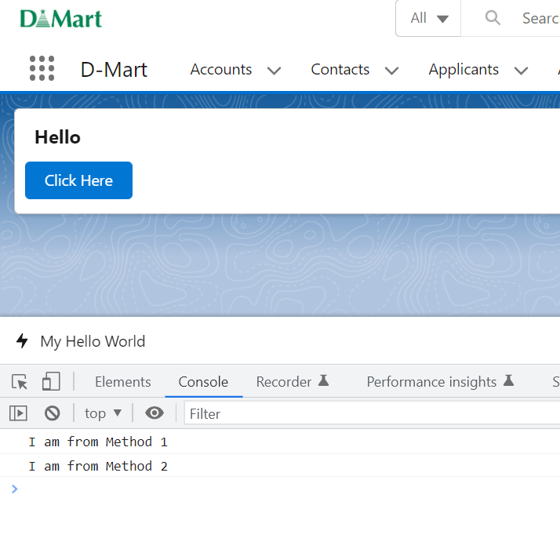

<template>

    <lightning-card  title="Hello">

        <lightning-button variant="brand" label="Click Here" title="Click Here" onclick={myMethod1} class="slds-m-left_x-small"></lightning-button>

    </lightning-card>

</template>

import SystemModstamp from '@salesforce/schema/Account.SystemModstamp';

import { LightningElement } from 'lwc';

export default class HelloWorld extends LightningElement {

    myMethod1(){

        console.log('I am from Method 1');

        this.myMethod2();

    }

    myMethod2(){

        console.log('I am from Method 2');

    }

}

=====================================================================================================

4] return values from a JS Method (get)

<template>

    <lightning-card  title="Hello">

        <lightning-button variant="brand" label="Click Here" title="Click Here" onclick={myMethod1} class="slds-m-left_x-small"></lightning-button>

    </lightning-card>

</template>

import SystemModstamp from '@salesforce/schema/Account.SystemModstamp';

import { LightningElement } from 'lwc';

export default class HelloWorld extends LightningElement {

    myMethod1(){

        console.log(this.myMethod2);

    }

    get myMethod2(){

       return 'I am from Method 2';

    }

}

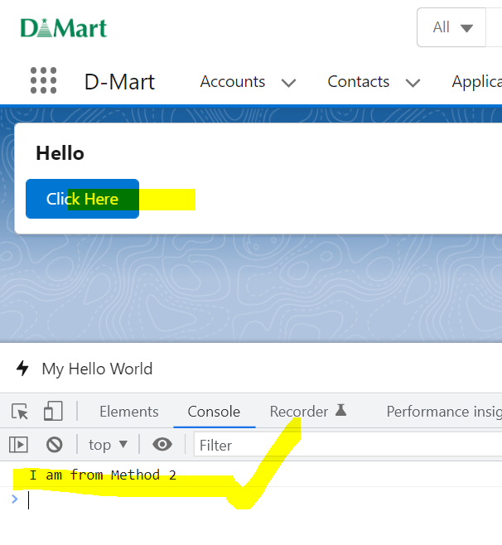

5] Input Fields

<lightning-input type="text" label="Enter some text"></lightning-input>

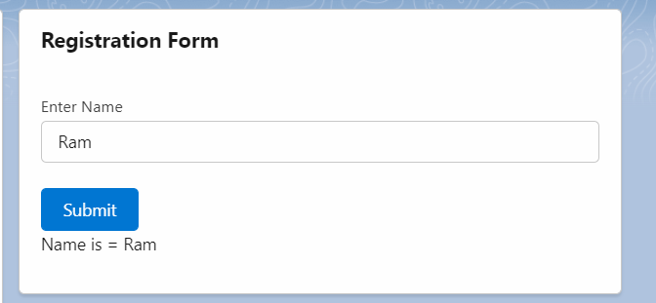

6] query Selector (GET and SET)

* **For Single input field**

this.template.querySelector('lightning-input').value

|  |  |
| --- | --- |
|  | |
|  |  |

<template>

    <lightning-card  title="Registration Form">

        <lightning-input type="text" label="Enter Your Name" name="firstName" ></lightning-input> <br />

        <lightning-button variant="brand" label="Submit" title="Submit" onclick={handleButton} class="slds-m-left_x-small"></lightning-button> <br />

        Your Name = {name}

    </lightning-card>

</template>

import SystemModstamp from '@salesforce/schema/Account.SystemModstamp';

import { LightningElement } from 'lwc';

export default class HelloWorld extends LightningElement {

    name

   handleButton(){

        this.name =  this.template.querySelector('lightning-input').value //Ram

   }

}

6] query Selector (GET)

* **For Multiple Fields**

var inputFields=this.template.querySelectorAll("lightning-input");

inputFields.forEach(element=>{

if(element.name=='firstName'){

this.firstName= element.value;

}

if(element.name=='lastName'){

this.lastName= element.value;

}

});

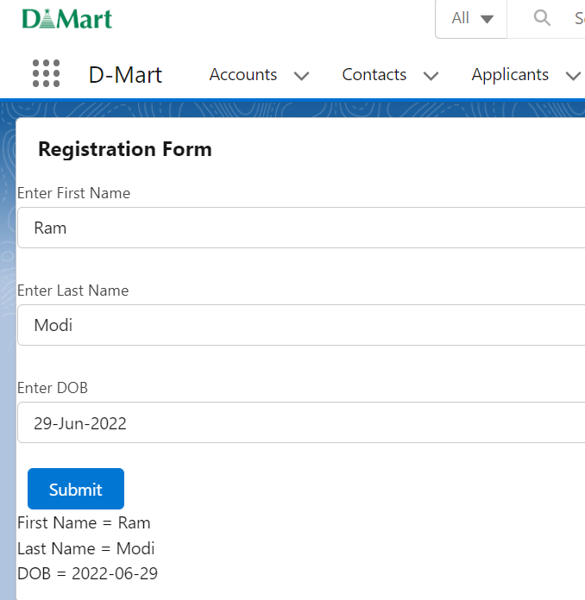



|  |  |
| --- | --- |
|  | |
|  |  |

<template>

    <lightning-card  title="Registration Form">

        <lightning-input type="text" label="Enter First Name" name="firstName" ></lightning-input> <br />

        <lightning-input type="text" label="Enter Last Name" name="lastName" ></lightning-input> <br />

        <lightning-input type="date" label="Enter DOB" name="dob" ></lightning-input> <br />

        <lightning-button variant="brand" label="Submit" title="Submit" onclick={handleButton} class="slds-m-left_x-small"></lightning-button> <br />

        First Name = {firstName} <br />

        Last Name = {lastName} <br />

        DOB = {dob}

    </lightning-card>

</template>

import SystemModstamp from '@salesforce/schema/Account.SystemModstamp';

import { LightningElement } from 'lwc';

export default class HelloWorld extends LightningElement {

    firstName

    lastName

    dob

   handleButton(){

    var inputFields=this.template.querySelectorAll("lightning-input");

    inputFields.forEach(element=>{

        if(element.name=='firstName'){

          this.firstName =    element.value;

        }

        if(element.name=='lastName'){

          this.lastName =    element.value;

        }

        if(element.name=='dob'){

            this.dob =    element.value;

          }

    });

   }

}

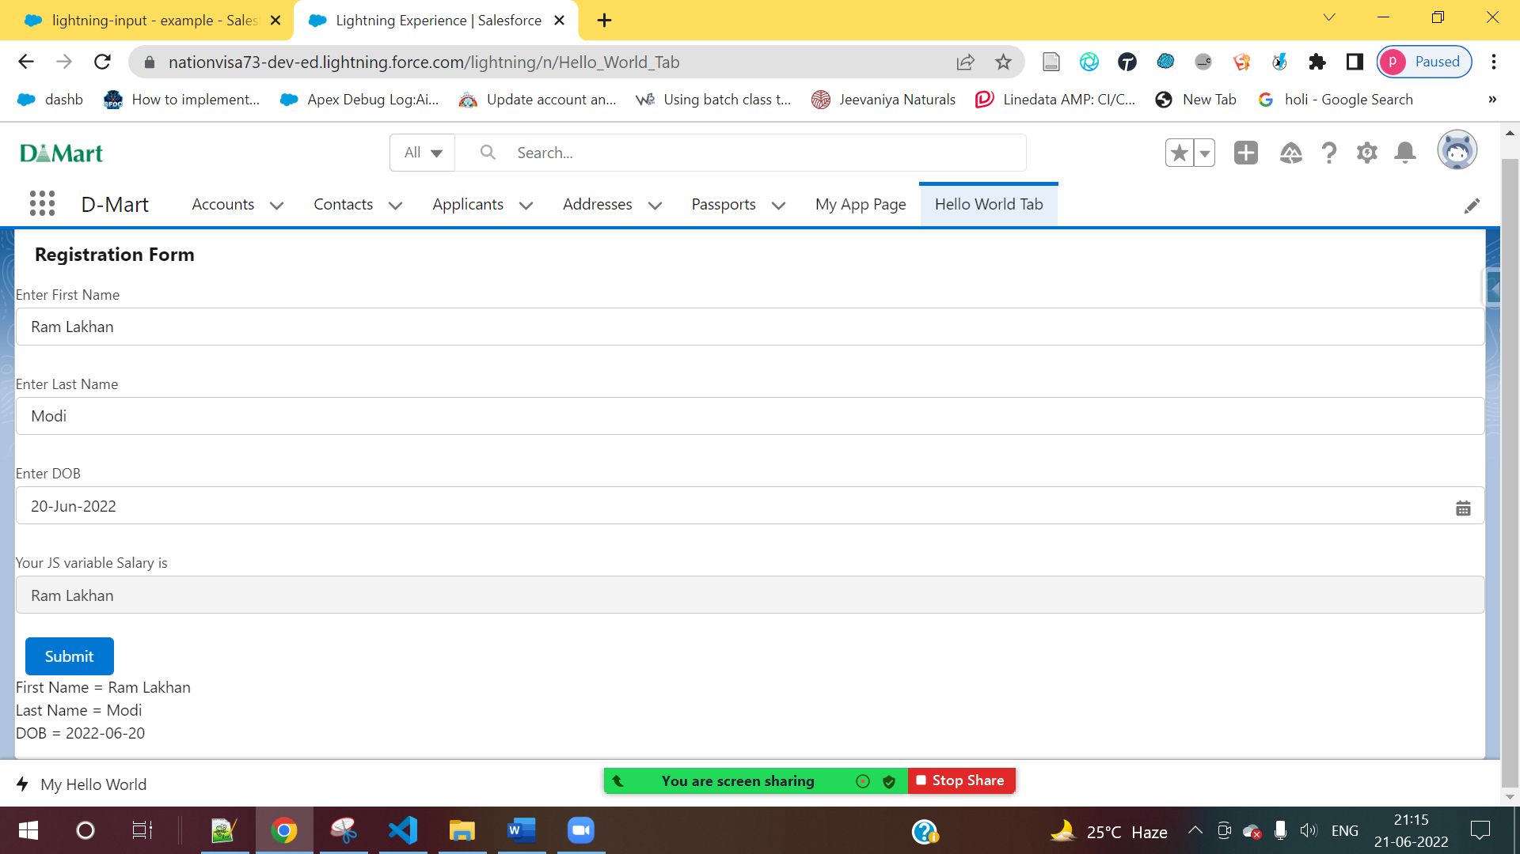

<template>

    <lightning-card  title="Registration Form">

        <lightning-input type="text" label="Enter First Name" name="firstName" ></lightning-input> <br />

        <lightning-input type="text" label="Enter Last Name" name="lastName" ></lightning-input> <br />

        <lightning-input type="date" label="Enter DOB" name="dob" ></lightning-input> <br />

        <lightning-input type="text" label="Your JS variable Salary is " name="yourFirstName" value={yourFirstName} disabled="true"></lightning-input> <br />

        <lightning-button variant="brand" label="Submit" title="Submit" onclick={handleButton} class="slds-m-left_x-small"></lightning-button> <br />

        First Name = {firstName} <br />

        Last Name = {lastName} <br />

        DOB = {dob}

    </lightning-card>

</template>

import SystemModstamp from '@salesforce/schema/Account.SystemModstamp';

import { LightningElement } from 'lwc';

export default class HelloWorld extends LightningElement {

    firstName

    lastName

    dob

    yourFirstName

   handleButton(){

    var inputFields=this.template.querySelectorAll("lightning-input");

    inputFields.forEach(element=>{

        if(element.name=='firstName'){

          this.firstName =    element.value;

          this.yourFirstName =  this.firstName ;

        }

        if(element.name=='lastName'){

          this.lastName =    element.value;

        }

        if(element.name=='dob'){

            this.dob =    element.value;

          }

    });

   }

}

**Assignment:**

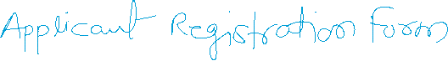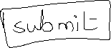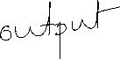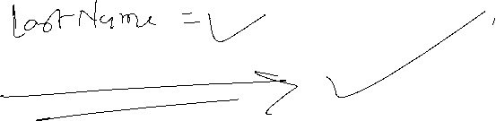

SET

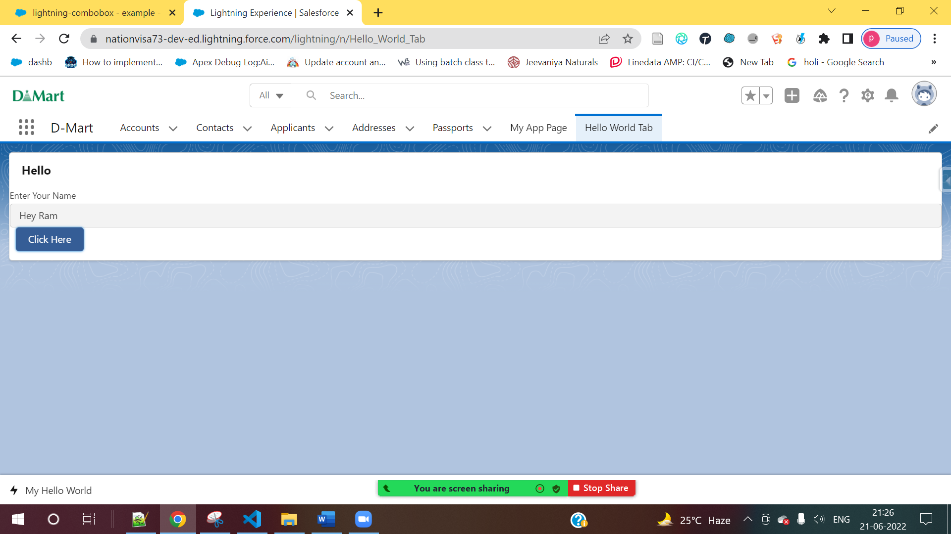

<template>

    <lightning-card  title="Hello">

        <lightning-input type="text" label="Enter Your Name" name="firstName" disabled="true"></lightning-input>

        <lightning-button variant="brand" label="Click Here" title="Click Here" onclick={handleButton} class="slds-m-left_x-small" ></lightning-button>

    </lightning-card>

</template>

import SystemModstamp from '@salesforce/schema/Account.SystemModstamp';

import { LightningElement } from 'lwc';

export default class HelloWorld extends LightningElement {

    name = 'Hey Ram'

   handleButton(){

     this.template.querySelector('lightning-input').value = this.name;

   }

}

